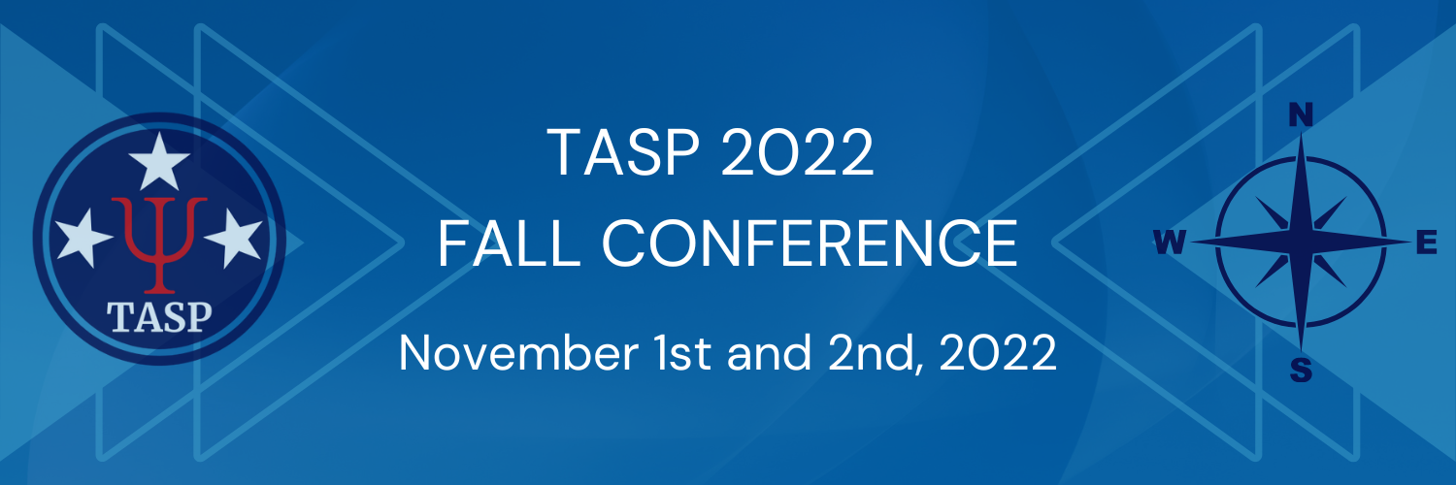

Call for Student Mini Research Presentations

The Tennessee Association for School Psychologists (TASP) announces a call for student research presentations for the 2022 TASP Fall Conference, to be held virtually on November 1-2, 2022.

Proposals for presentations will be reviewed and considered for inclusion in the conference if they are received by October 7, 2022. The session will be conducted virtually, and all presenters will be allotted 5 minutes to present on their research. All presentations should include any information, graphics, or visuals on a single Powerpoint Slide, which will be displayed during the virtual session. APA-style formatted presentation slides are acceptable but not required. A raffle drawing of presenters will be conducted for prizes.

Rules for Participation:
- Any undergraduate or graduate student may submit a research proposal.
- Proposals may include original empirical studies, program development/evaluation, critical literature review, meta-analysis, etc.
- For accepted presentations the first author must present at the conference research presentation session. You are welcome and encouraged to register and attend the rest of the conference events.

Procedures for Submitting Proposals:
Submissions should include:
- The Research Proposal cover sheet available on www.tasponline.org.
- A 500 word or less summary/abstract detailing the work and the proposed presentation

Proposals must be emailed to kristinwillocks@gmail.com by midnight on October 7, 2022.

Research Presentation Proposal Cover Sheet
2022 TASP FALL CONFERENCE

Title of Presentation:

Principal (presenting) Author:
Full Name:

Highest Educational Degree:

Mailing Address:

Phone Number:

E-mail Address:

Membership Status:
◻ TASP Student Member ◻ Non-member

Coauthors (Please list names in order, including any obtained degrees):
1st Coauthor
2nd Coauthor
3rd Coauthor

Please attach research summary/abstract. Proposals must be emailed to kristinwillocks@gmail.com by midnight on October 7, 2022

